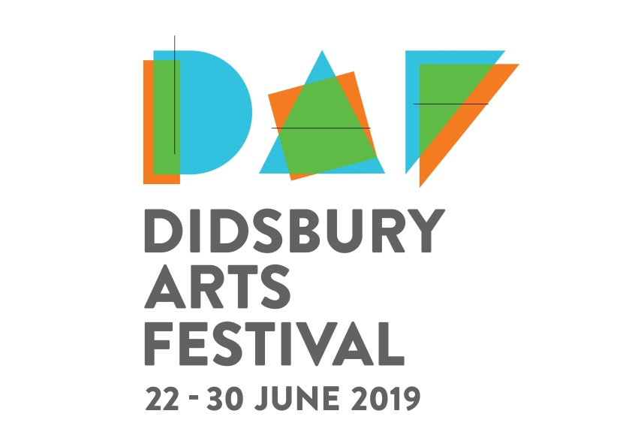
Major sponsors announced for Didsbury Arts Festival 2019
Local companies answer the call to be curious!

Five local businesses have been named as major sponsors of Didsbury Arts Festival 2019.
Engineering giant Siemens, developers PJ Livesey, and customer experience experts ABa Quality Monitoring have been named as ‘gold’ sponsors, supporting the nine-day festival, whose theme, this year, is ‘Curiosity’. In addition, DAF is supported by ‘silver’ sponsors, Spire Manchester Hospital and Stealth Design. Between them, the five sponsors will make a significant contribution to the funding necessary to stage the festival, taking place from 22 to 30 June. All five businesses have supported DAF in previous years.
A decade since its inception in 2009, the thriving, community arts festival attracts 14,000 visitors to nearly 100 events. A large number of events are free or subsidised, making the volunteer-led festival accessible to all. Organisers are preparing for a landmark festival this year as DAF celebrates its tenth anniversary.
‘This year’s festival promises to be bigger and better than ever. Our aim is to make it an even more inclusive experience and to reach out to a wider and more diverse audience across Manchester, as well as to the local, south Manchester community,’ said Maria Stripling, Chair of the DAF Board.
‘The generous support of our gold and silver sponsors provides an anchor to the festival and ensures its high quality. As we now go into the intensive programme development period we can be confident of delivering an event that exceeds expectations.’
The five gold and silver sponsors recently joined other local stakeholders and patrons for a special reception, where festival director, Ella Wild, unveiled plans and branding for the 2019 programme. The evening was held at the Maggie’s Centre Manchester and featured performances from the Siemens Choir and Maggie’s own creative writing group.
PJ Livesey director James Woodmansee, said: ‘The Festival is a wonderful mix of art, music and theatre that embraces the whole area and celebrates the strength of the community. We are very happy to support and play our small part in making it happen and hope everyone has the dates firmly in their diary.’
Sue Bagguley, Head of Business Development at Siemens Digital Industries, said: ‘We are delighted once again to be supporting the Didsbury Arts Festival and we look forward to being a part of the event and providing opportunities for our people to be involved. Having been a neighbour in Didsbury for the past 30 years it is a pleasure to be able to support a community event with such diversity.’
Kate and Conrad Jacobson, company owners of Aba Quality Monitoring, said: ‘ABa Quality Monitoring is so proud to be a long term sponsor of DAF and to see each festival surpass the last in terms of programme content and visitor numbers.
‘We have been residents of Didsbury for over 35 years - the Didsbury Arts Festival enhances our local environment and reinforces a sense of community.’
Jill Taylor, Director of Stealth Design, said: ‘Art is an important part of what pulls a community together and so Stealth are proud to be supporting Didsbury Arts Festival since 2010.’
Andrew Eadsforth, Hospital Director at Spire Manchester Hospital said: ‘We are delighted to be supporting Didsbury Art Festival for the second year running. The festival is a fantastic opportunity to celebrate stunning art, music and theatre with the local community. It is a pleasure to support and we hope the festival continues to grow for many years to come.’
Visit the DAF website for news about the festival programme (live from early April) and highlights: www.didsburyartsfestival.org.uk
ENDS
MEDIA CONTACT: Deborah Grace, press@didsburyartsfestival.org 07979 908 871

